|  |  |
| --- | --- |
| **NAME** | **AHAMED ALI.H** |
| **TEAM ID** | **PNT2022TMID37442** |
| **PROJECT TITLE** | **IoT Based Safety Gadget for Child Safety Monitoring and Notification** |

**ASSIGNMENT- 4**

**write code and connections in wokwi for ultrasonic sensor . whenever distance is less 100 cms send "alert"to ibm cloud and display in device recent event**

program

#define trigPin 12

#define echoPin 13

int Buzzer = 8; // Connect buzzer pin to 8

int ledPin= 6; //Connect LEd pin to 6

int duration, distance; //to measure the distance and time taken

void setup() {

Serial.begin (9600);

//Define the output and input objects(devices)

pinMode(trigPin, OUTPUT);

pinMode(echoPin, INPUT);

pinMode(Buzzer, OUTPUT);

pinMode(ledPin, OUTPUT);

}

void loop() {

digitalWrite(trigPin, HIGH);

delayMicroseconds(10);

digitalWrite(trigPin, LOW);

duration = pulseIn(echoPin, HIGH);

distance = (duration/2) / 29.1;

//when distance is greater than or equal to 200 OR less than or equal to 0,the buzzer and LED are off

if (distance >= 200 || distance <= 0)

{

Serial.println("no object detected");

digitalWrite(Buzzer,LOW);

digitalWrite(ledPin,LOW);

}

else {

Serial.println("object detected \n");

Serial.print("distance= ");

Serial.print(distance); //prints the distance if it is between the range 0 to 200

tone(Buzzer,400); // play tone of 400Hz for 500 ms

digitalWrite(ledPin,HIGH);

}

}

**Output**

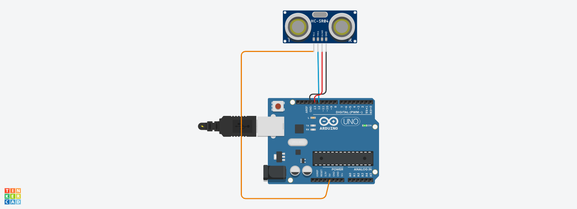

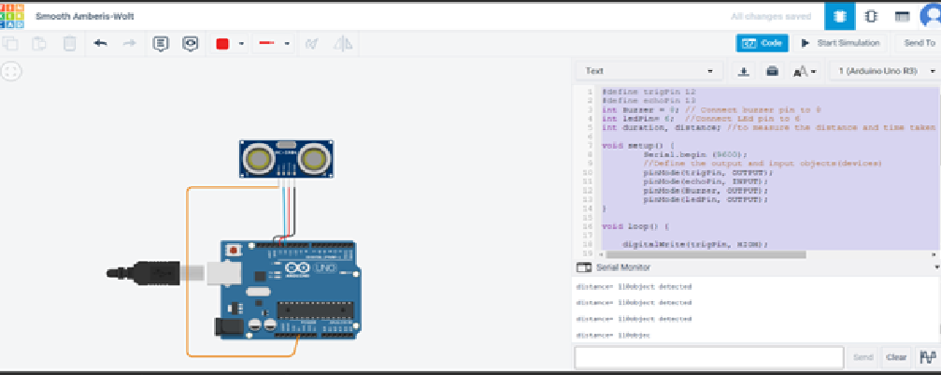

Distance= 110 object detected